**TELECOMMUNICATION FRANCHISE MANAGEMENT SYSTEM**



**Session: 2021 – 2024**

**Submitted by:**

Muhammad Farman

2021-CS-132

**Supervised by:**

Dr. Awais

Department of Computer Science

**University of Engineering and Technology**

**Lahore Pakistan**

Table of Contents

Description 3

Users 3

WireFrames 3

Sign Up 3

Sign In 4

Sign in as Admin 4

Sign in as Customer: 8

# Description

This application will help telecommunication franchises to manage their tasks more efficiently and effectively. It will help not only manager and workers but also the users of telecommunication company.

# Users

This application can be used by multiple people but there are only three roles:

1. Admin
2. User

# WireFrames

Sign Up :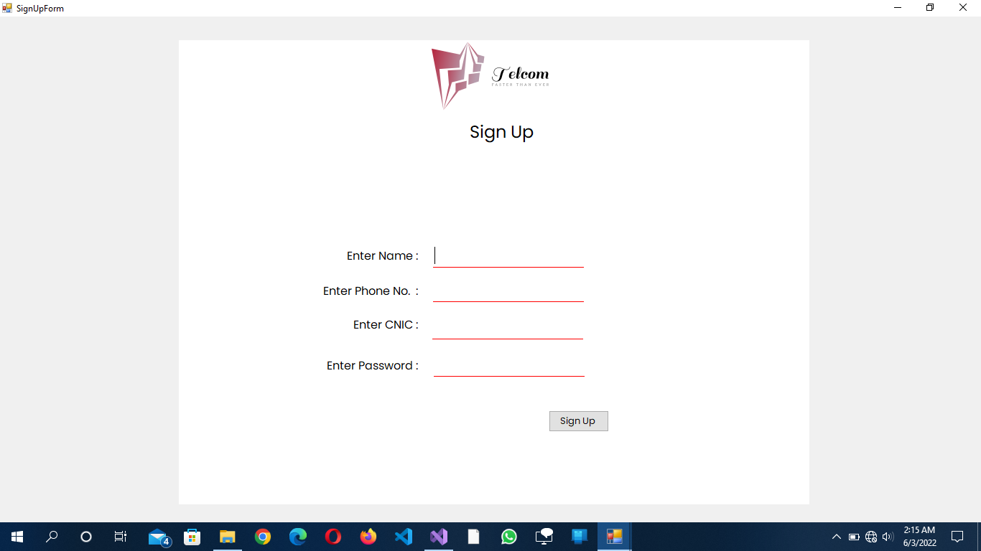

Sign In :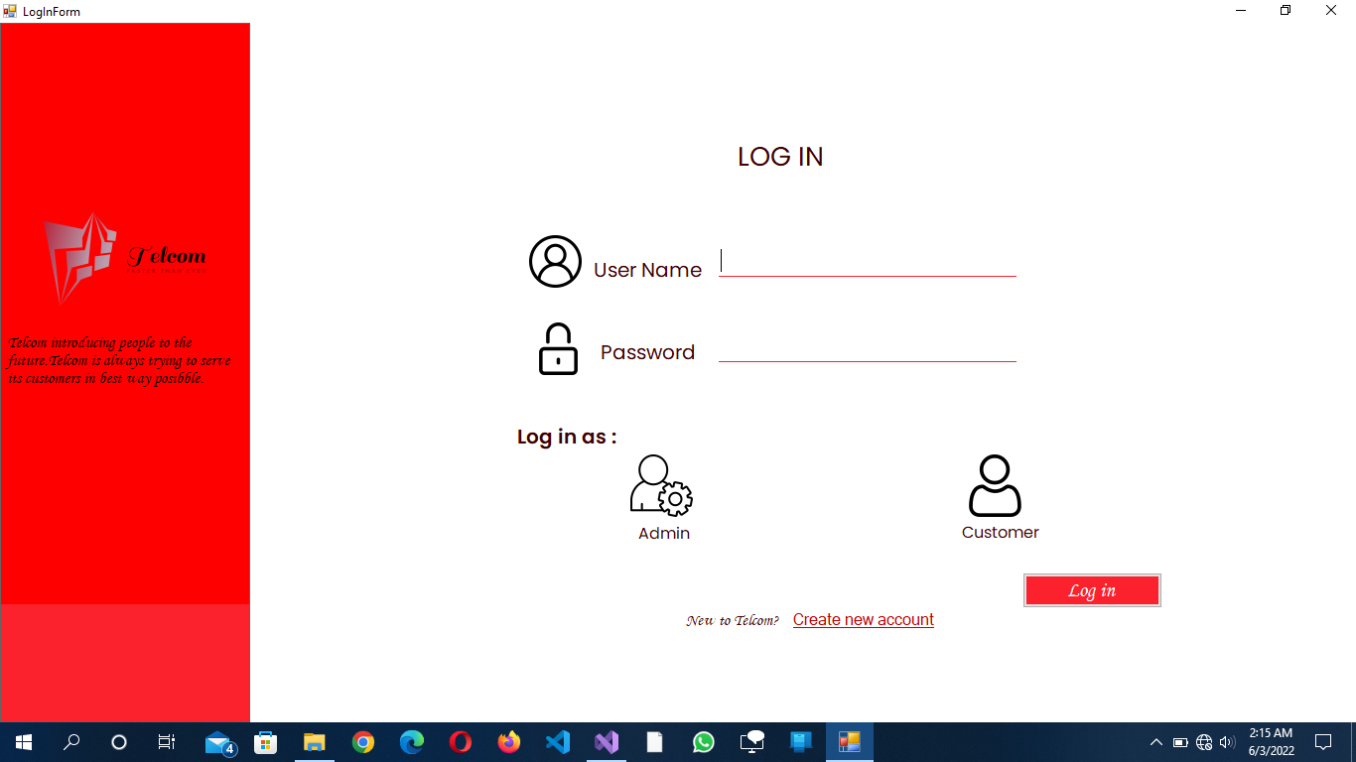

Sign in as Admin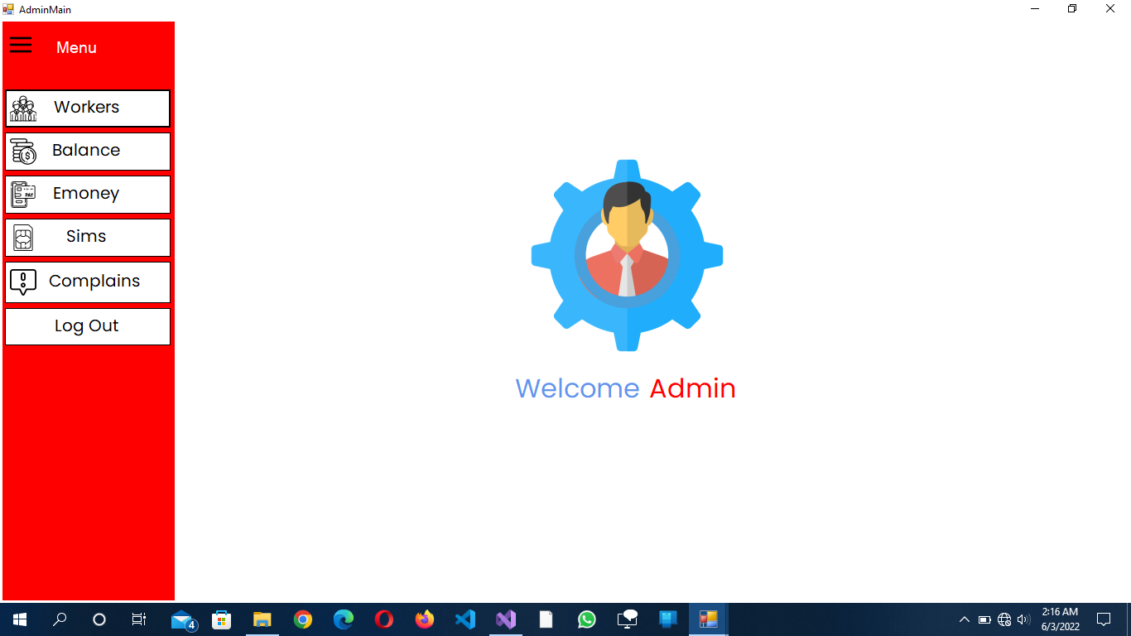

Click on Workers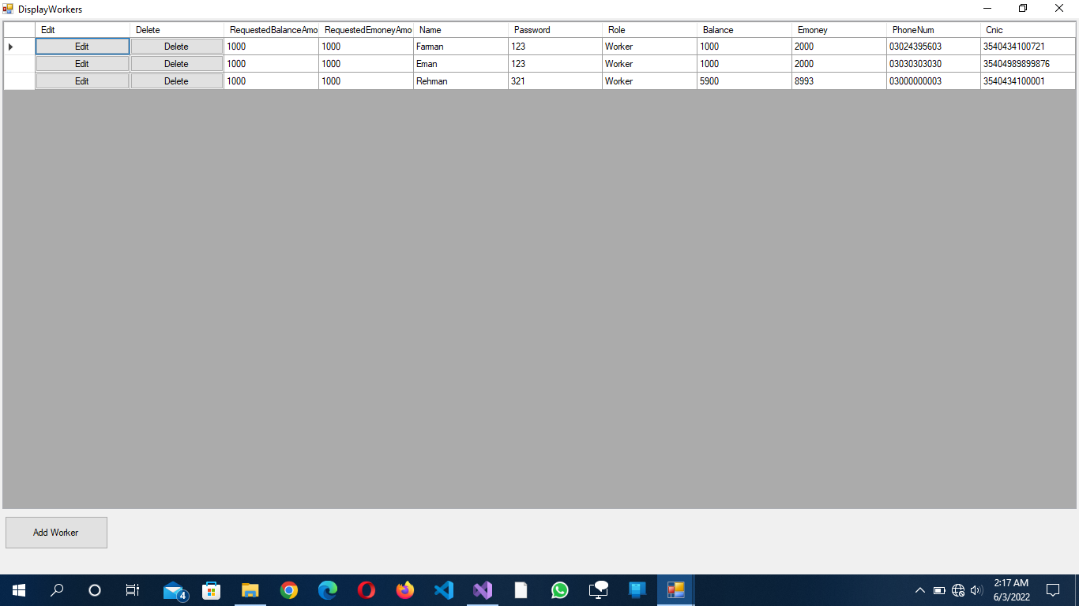

Click on Add Worker :

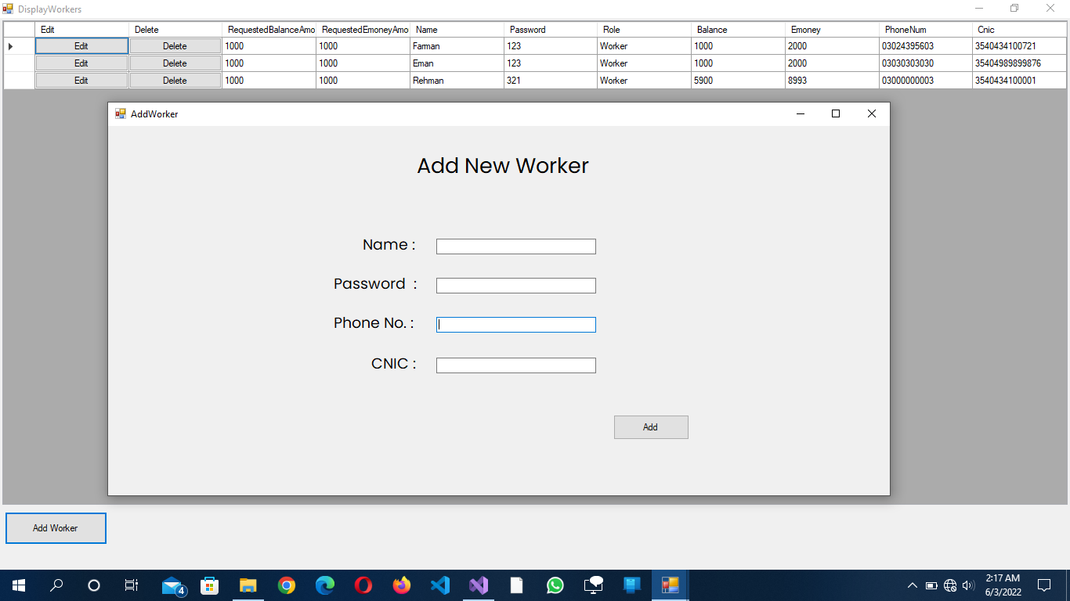

Click on Balance :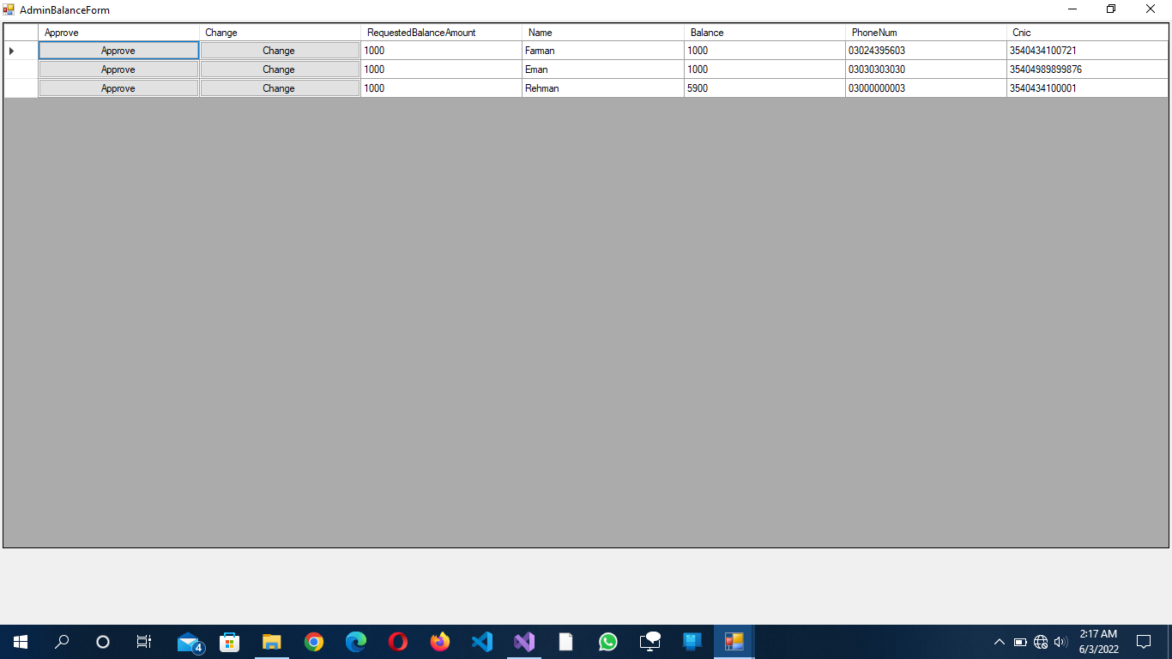

Click on Emoney:

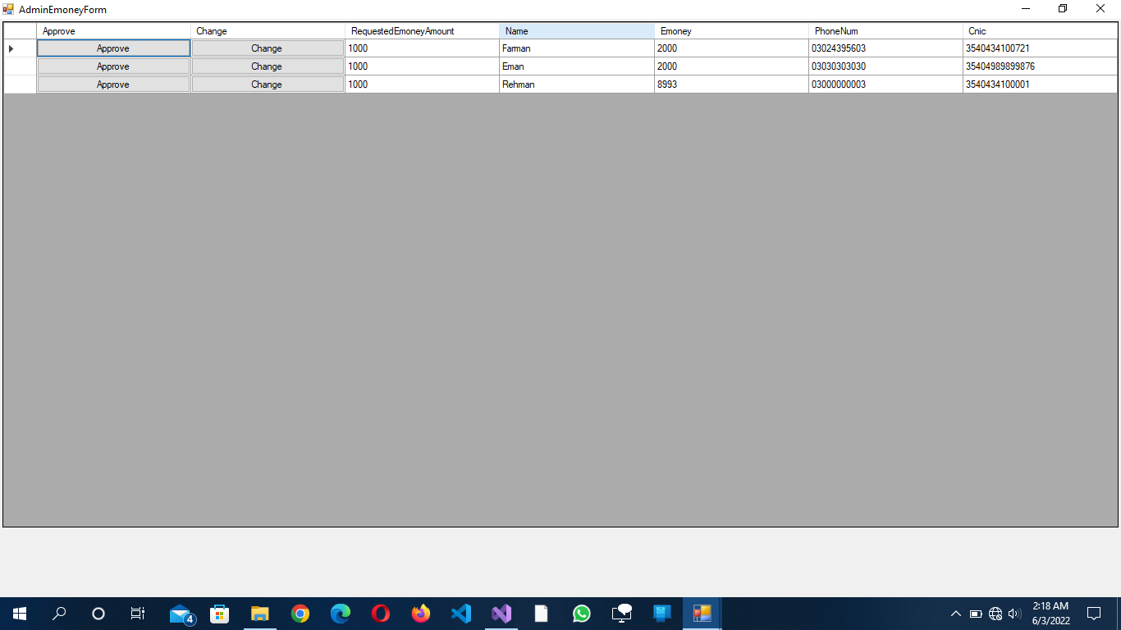

Click on Sims:

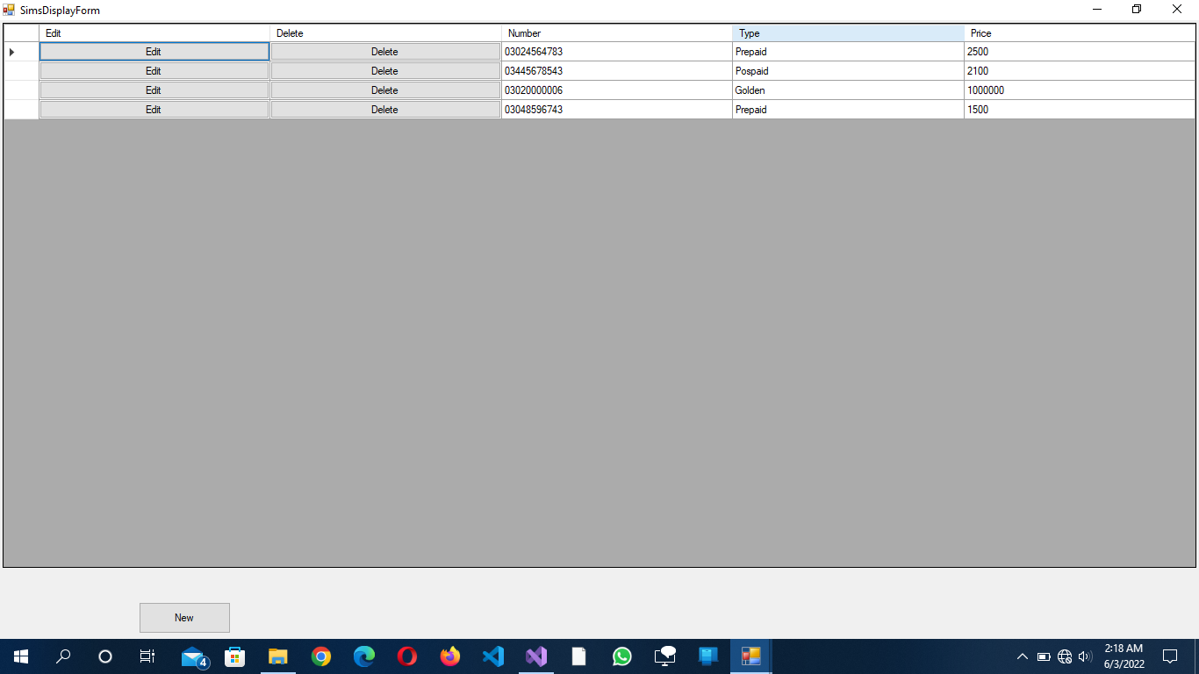

Click on Add New Sim;

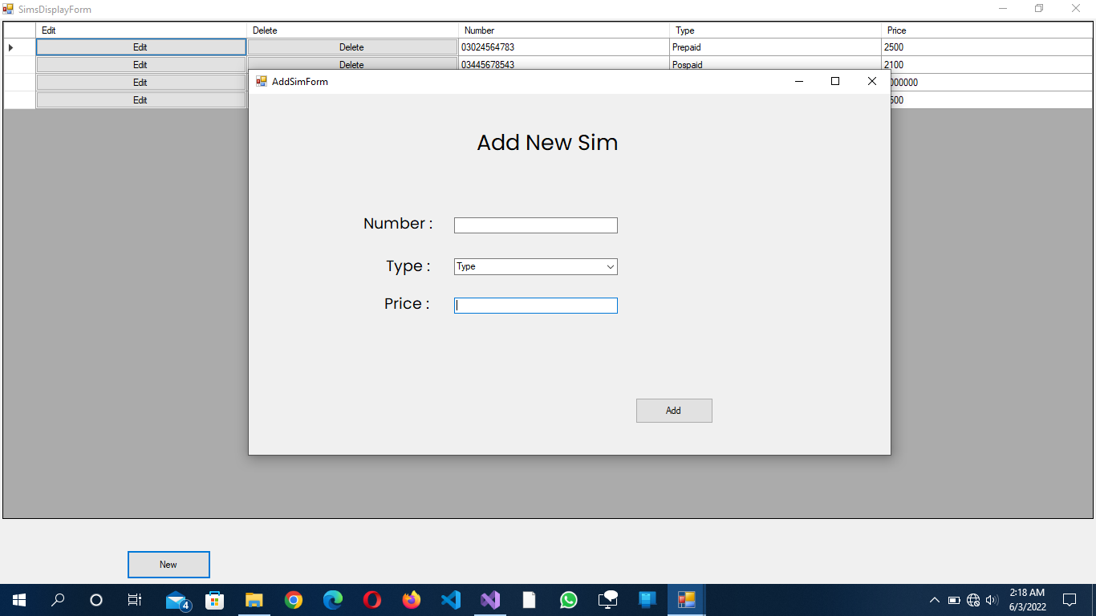

Click on Complains Report:

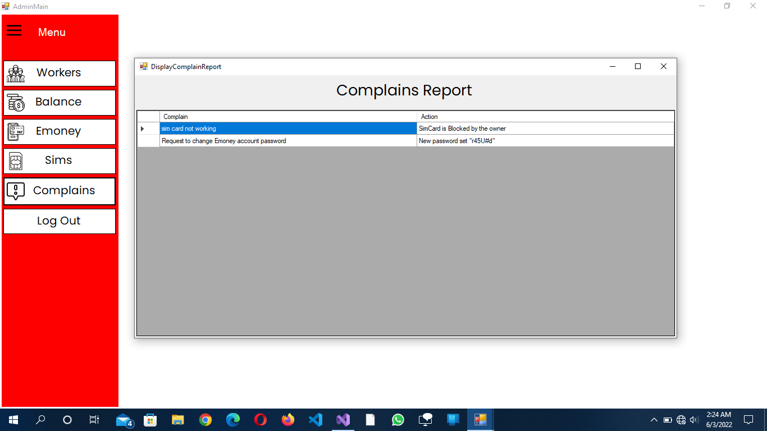

## Sign in as Customer:

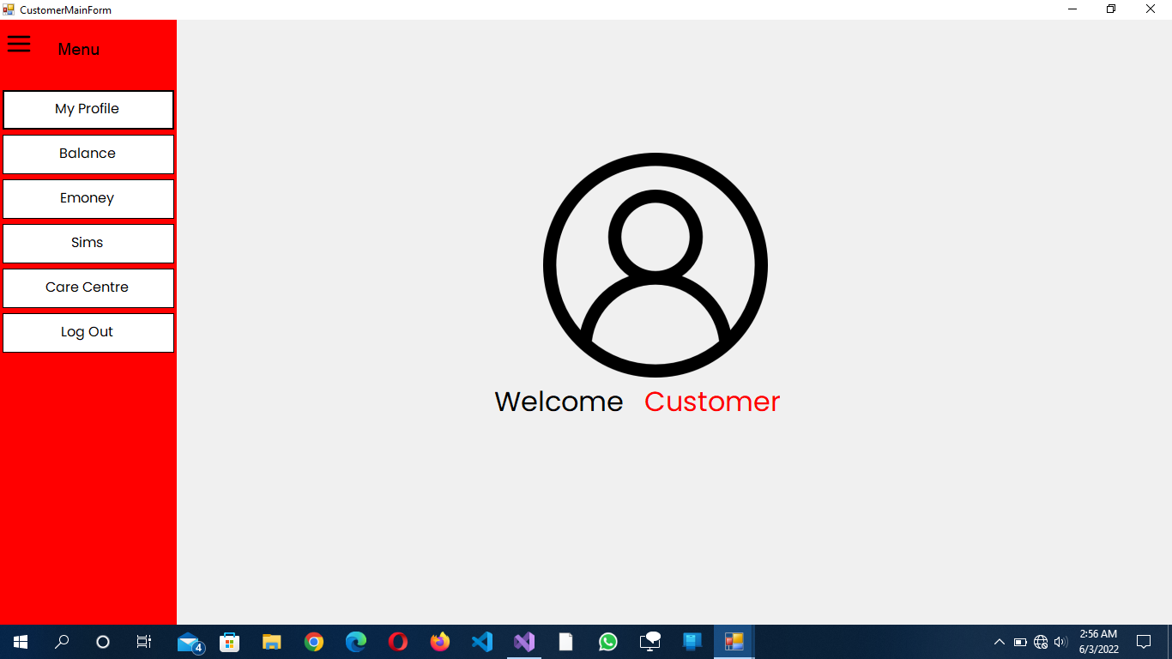

Click on My Profile: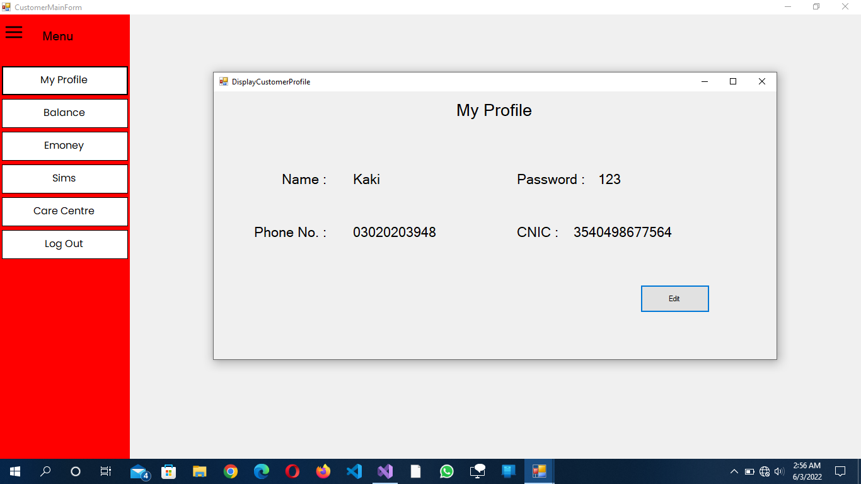

Click on Edit :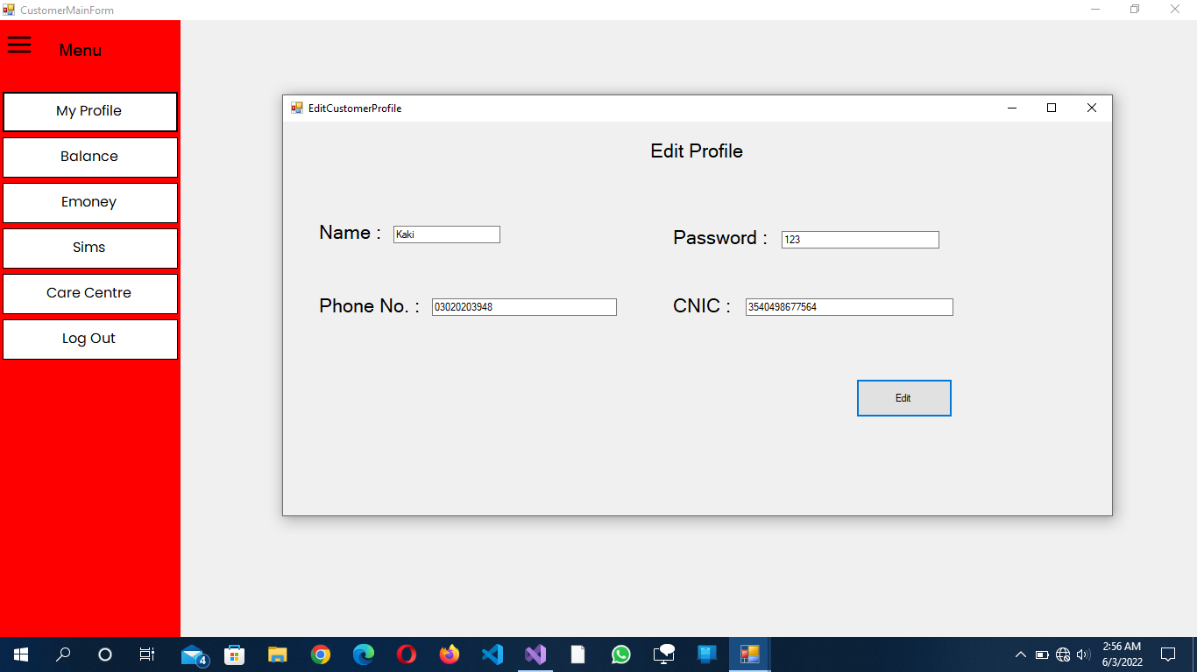

Click on Balance :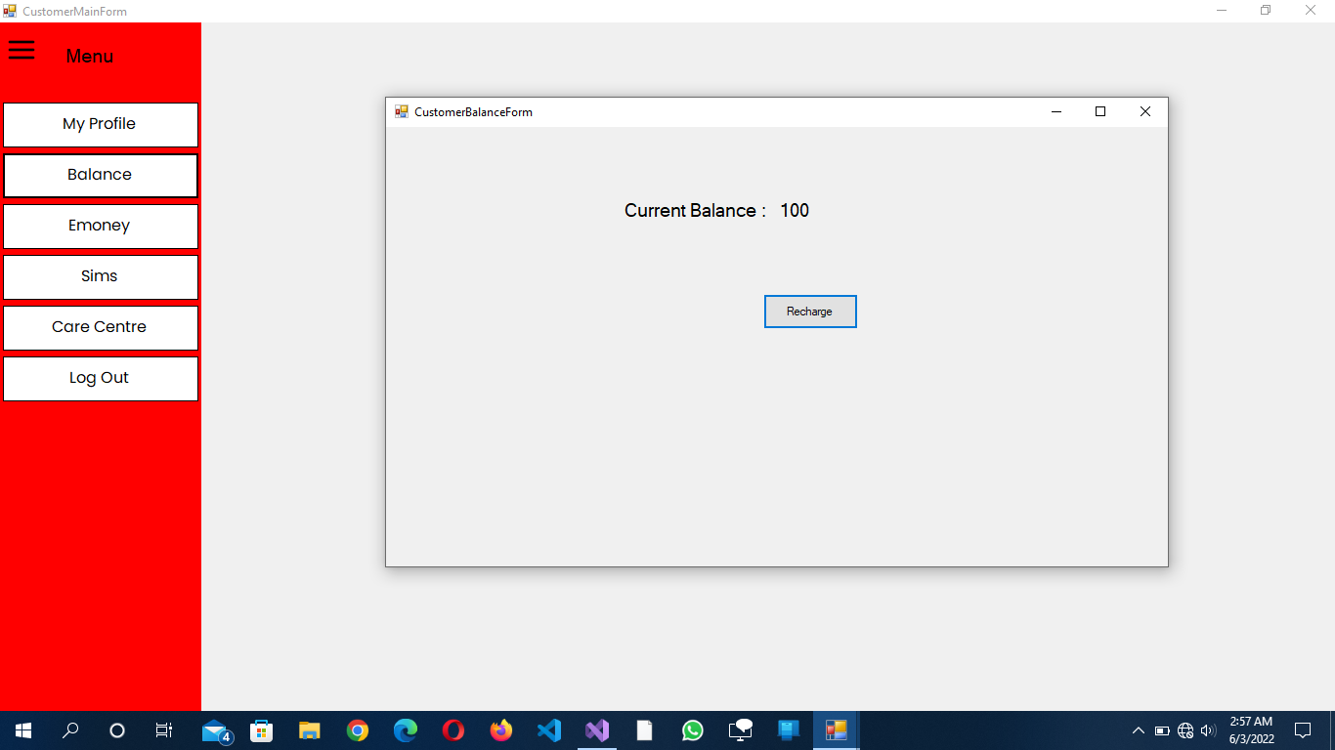

Click on Recharge: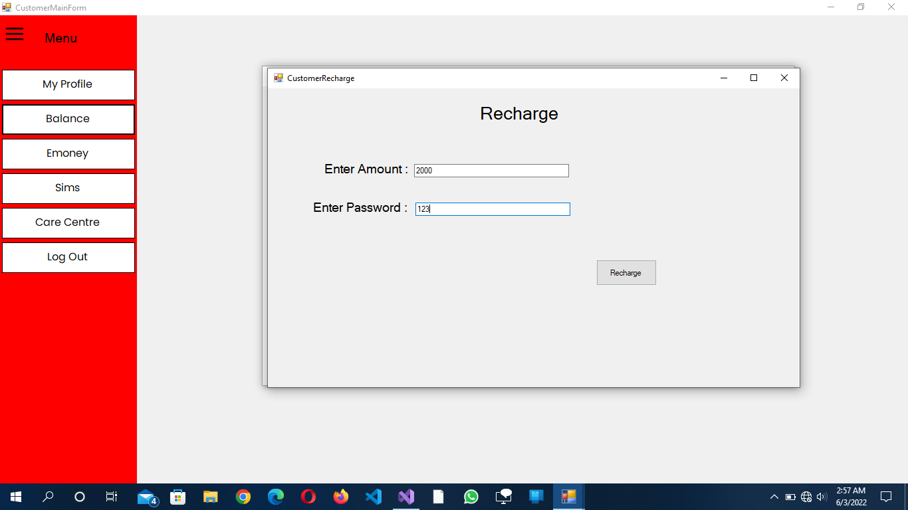

Click on Emoney :

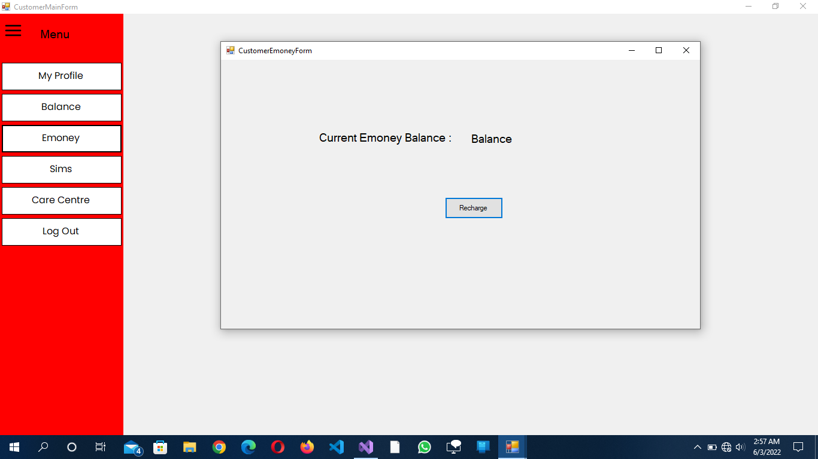

Click on Recharge :

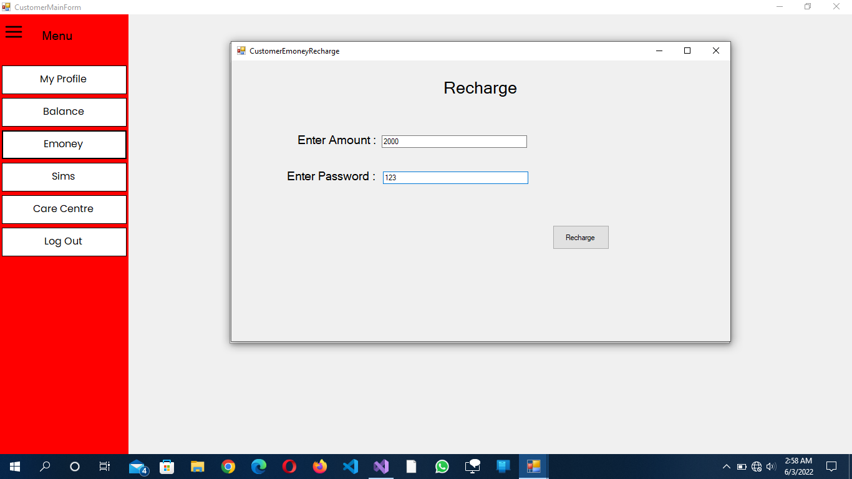

Click on Sims:

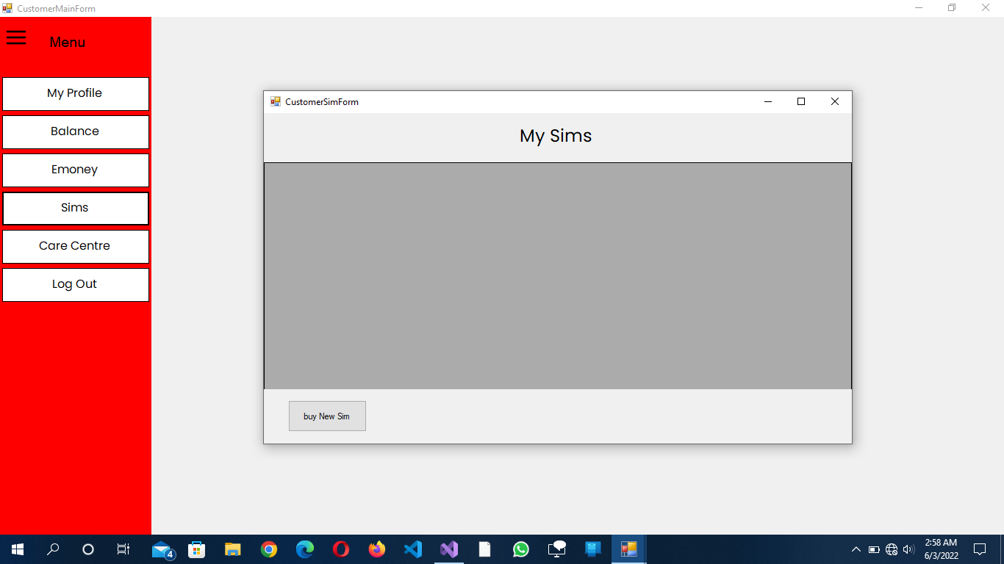

Click on Buy New Sim:

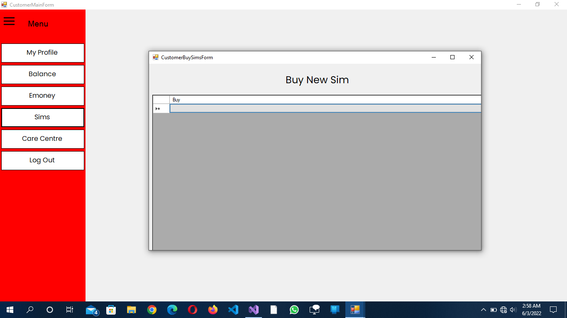

Click on Care Centre:

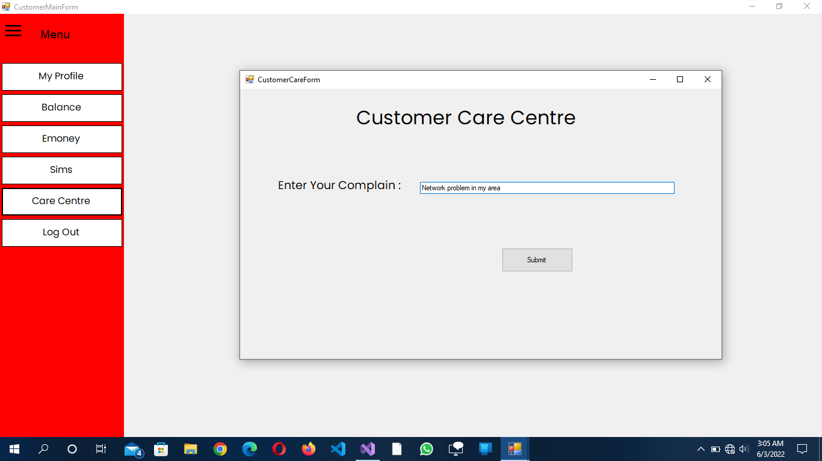

# Domain Model

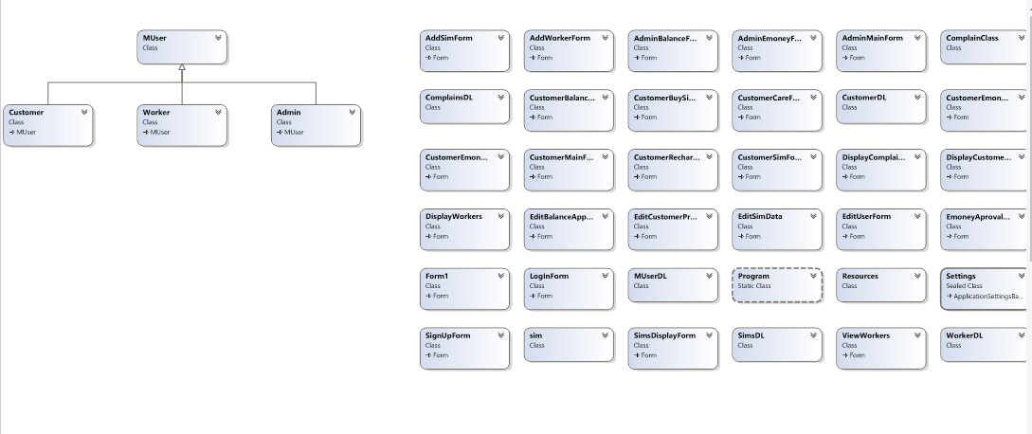

## With Relation

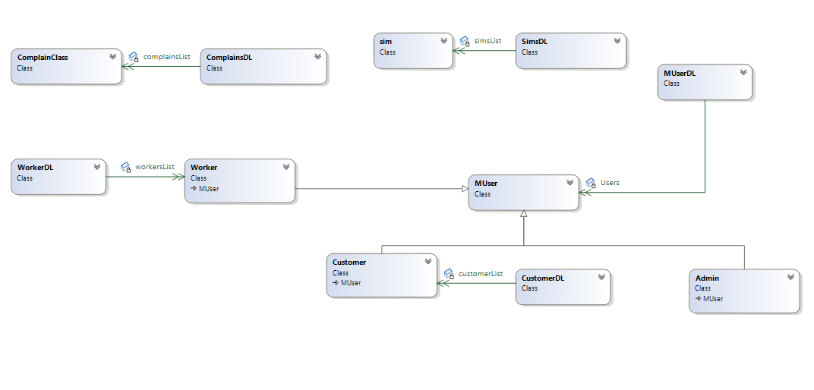

# Class Diagram

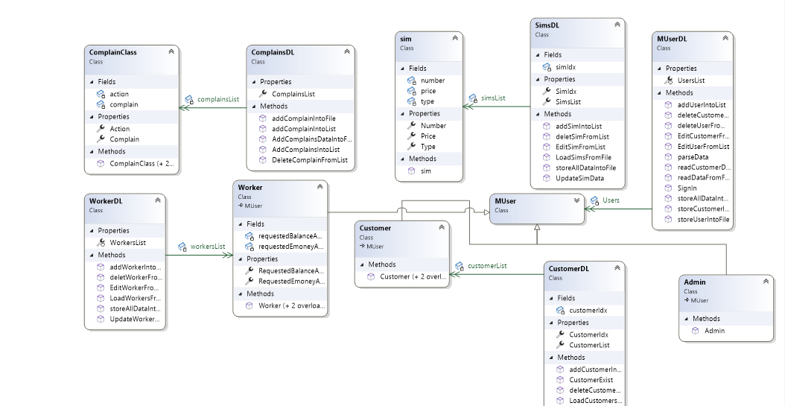

#### User

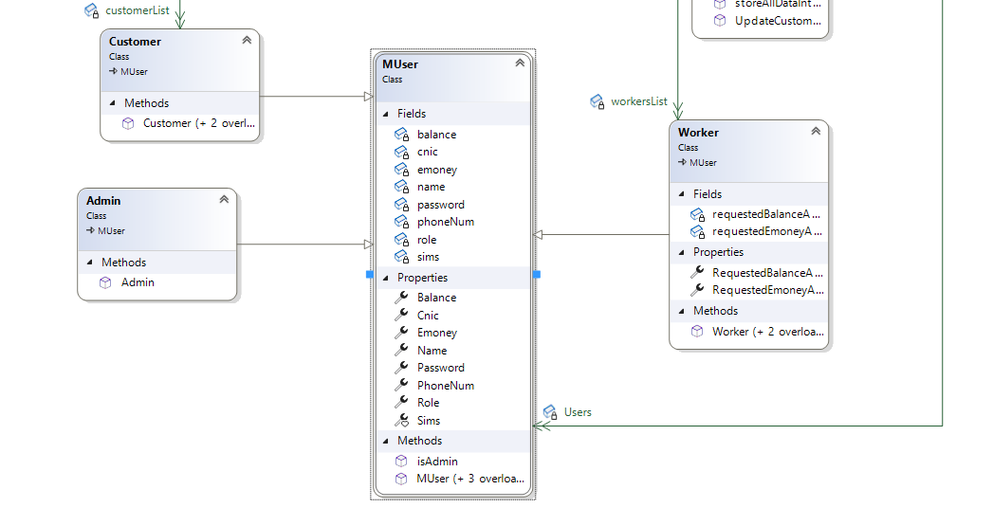

# Sequence Diagram

Start







If customer select Emoney



If Customer select Sims



If Customer Select Customer Care

